

PET ENGINEERING COLLEGE

VALLIOOR - 627117


DEPARTMENT OF ARTIFICIAL INTELLIGENCE AND DATA SCIENCE
PROJECT TITLE: EDUCATIONAL ORGANISATION USING SERVICENOW

College Code: 9632

Technology: Artificial Intelligence

Total number of student’s in a group: 4

Student’s details within the group:

M.MOHAMED FARITH (Reg. no: 963222243013)

B.MOHAMMED MOHIDEEN IDRIS (Reg.no: 963222243015)

A.MUTHU SANKARI (Reg.no: 963222243016)

I.MUTHU SELVI SOWMEYA (Reg.no: 963222243017)

BONAFIDE CERTIFICATE

Certified that this project report " EDUCATIONAL ORGANISATION USING

SERVICENOW” is the bonafide work of M.MOHAMED FARITH (963222243013)

who carried out the work under my supervision. Certified further that to the best of my

knowledge the work reported here in does not form part of any other thesis or dissertation on

the basis of which a degree or award was conferred on an earlier occasion on this or any other

candidate.

Signature Signature

Mrs.PRAPHA.G DR.T.THANYA

Assistant Professor, Head of the Department

Department of AI&DS, Department of AI&DS,

PET EngineeringCollege, PET EngineeringCollege,

Vallioor Vallioor

INTERNAL EXAMINER EXTERNAL EXAMINER

TABLE OF CONTENTS

- Introduction

- Ideation phase
- Requirement phase
- Project Design
- Project planning & Scheduling
- Functional & Performance Testing

- Results
- Advantages & Disadvantages

- Conclusion

- Future Scope

- Appendix

EDUCATIONAL ORGANISATION USING SERVICENOW

1.INTRODUCTION

  - Project Overview
This project, "Educational Organisation Using ServiceNow", aims to digitize and streamline core operations within an educational institution by leveraging the ServiceNow platform. The objective is to build a centralized system that automates processes such as student admissions, faculty onboarding, academic tracking, and administrative workflows. By creating custom tables, forms, workflows, and business rules, the project seeks to enhance operational efficiency, reduce manual effort, and improve transparency across departments.
  - Purpose
The Educational Organisation Using ServiceNow project aims to enhance the efficiency and transparency of academic and administrative operations within an educational institution. The application will allow users to:
- Manage student admissions and academic records through automated workflows
- Track faculty onboarding, course assignments, and performance metrics
- Handle administrative tasks such as leave requests, asset management, and event approvals
- Generate dashboards and reports for data-driven decision-making across departments

2. IDEATION PHASE

2.1.Problem Statement

The project aims to develop a comprehensive educational management system using the ServiceNow platform. This system will enable institutions to efficiently manage student admissions, academic performance, faculty onboarding, and administrative operations. Educational organizations often face challenges in handling large volumes of data manually, leading to inefficiencies, delays, and lack of transparency.
Traditional methods such as paper-based records or disconnected spreadsheets are time-consuming, error-prone, and make it difficult to track progress, generate reports, or maintain accountability across departments. Institutions struggle to coordinate between academic and administrative units, especially when managing student records, faculty tasks, and infrastructure requests.
To overcome these challenges, there is a need for a digital solution built on the ServiceNow platform that can automate and streamline educational workflows. The system should allow users to manage student data, course registrations, faculty assignments, and administrative requests through custom forms, tables, and approval workflows. It should also support dashboards for performance tracking, notifications for pending tasks, and secure data management.

Utilizing ServiceNow’s robust capabilities, the project will ensure seamless integration, a user-friendly interface, and scalability to accommodate institutions of varying sizes and complexities. The end goal is to empower educational organizations with the tools they need to enhance operational efficiency, improve decision-making, and deliver a better experience for students, faculty, and administrators.

2.2. Empathy Map Canvas
- Entities:
- Student: Represents an individual enrolled in the institution
  - Attributes: Name, Roll Number, Course, Year, Contact Info
- Faculty: Represents teaching and administrative staff
  - Attributes: Name, Department, Role, Contact Info, Assigned Courses
- Course: Represents academic subjects offered
  - Attributes: Course Code, Title, Credits, Faculty Assigned
- Admission: Represents student enrollment details
  - Attributes: Student ID, Admission Date, Program, Status
- Leave Request: Represents leave applications by students or faculty
  - Attributes: Requester, Type, Duration, Reason, Approval Status
- Event: Represents campus events and activities
  - Attributes: Title, Date, Organizer, Venue, Participants
- Asset: Represents physical or digital resources used by the institution
  - Attributes: Asset ID, Type, Location, Assigned To, Status

- Map Canvas:
The map canvas would visualize relationships between these entities, showing:
- Student records linked to Admission, Course, and Leave Request entities
- Faculty records connected to Course, Leave Request, and Event entities
- Course records associated with both Student and Faculty entities
- Event records involving Faculty, Student, and Asset entities
- Asset records assigned to specific Faculty, Departments, or Events
This entity and map canvas design will help structure the educational data model in ServiceNow, enabling effective workflow automation, data relationships, and reporting capabilities across the institution.
2.3. Brainstroming
Brainstroming: Educational Organisation Using ServiceNow
Ideas:
- Automated Student Admission Workflow: Use ServiceNow to automate the entire admission process, including application submission, document verification, and approval.
- Faculty Onboarding and Assignment: Create workflows for onboarding new faculty members and assigning them to courses and departments.
- Academic Performance Tracking: Develop dashboards to monitor student grades, attendance, and progress across semesters.
- Leave and Attendance Management: Implement leave request workflows for students and faculty, integrated with attendance tracking.
- Event and Resource Booking System: Enable departments to schedule events and reserve resources like classrooms, labs, and equipment.
- Administrative Request Portal: Allow staff and students to raise requests for services like maintenance, IT support, or document issuance.
- Custom Reporting and Analytics: Generate real-time reports on academic performance, resource utilization, and administrative efficiency.
Questions:
- How can we ensure secure access to sensitive academic and personal data?
- What integrations are needed with existing ERP or LMS systems?
- How can we tailor the solution to suit different types of educational institutions (e.g., schools, colleges, universities)?
- What role-based access controls should be implemented for students, faculty, and administrators?
This brainstorming session explores innovative ways to digitize and optimize educational workflows using ServiceNow, aiming to improve efficiency, transparency, and user experience across the institution.
3. REQUIREMENT PHASE
3.1.Journey map
Journey Phase: Educational Organisation Using ServiceNow
- Phases:
- Discovery: Identify the operational challenges and digital needs of the educational institution
- Planning: Define the project scope, resource allocation, and implementation timeline
- Design: Configure ServiceNow to support educational workflows such as admissions, faculty onboarding, and academic tracking
- Implementation: Set up and test the solution across departments and user roles
- Adoption: Train students, faculty, and administrative staff to use the platform effectively
- Review and Refine: Continuously evaluate and enhance the system to meet evolving institutional needs
- Activities:
- Requirements Gathering: Identify key academic and administrative processes that need automation
- Solution Design: Design a ServiceNow-based solution using forms, workflows, dashboards, and reports
- Configuration and Testing: Configure the platform and conduct functional and performance testing
- Training and Adoption: Provide training sessions and user guides for all stakeholders
- Ongoing Monitoring and Maintenance: Monitor system performance and update features to ensure continued relevance and efficiency
This journey outlines the essential stages and activities involved in implementing a digital transformation solution for educational organizations using ServiceNow.
3.2. Solution Requirements
- Functional Requirements:
- Student Management: Ability to record and manage student profiles, academic records, and enrollment status
- Faculty Management: Ability to manage faculty profiles, course assignments, and leave requests
- Course Registration: Enable students to register for courses and track their academic progress
- Administrative Workflow Automation: Automate tasks such as leave approvals, event scheduling, and maintenance requests
- Reporting and Dashboards: Generate real-time reports on academic performance, resource usage, and administrative efficiency
- Non-Functional Requirements:
- Data Security: Ensure all academic and personal data is securely stored and accessed
- User Experience: Provide an intuitive and role-based interface for students, faculty, and administrators
- Scalability: Ensure the solution can scale to support institutions of varying sizes and complexities
- Integration: Ability to integrate with existing ERP, LMS, or HR systems
- Technical Requirements:
- ServiceNow Platform: Leverage ServiceNow’s capabilities including forms, workflows, notifications, and reports
- Data Modeling: Design a robust data model to manage students, faculty, courses, events, and requests
- Security Configuration: Implement role-based access control and data protection policies within ServiceNow

3.3 Data Flow Diagram
[User Input / Portal Access]
↓
[Student / Faculty / Course Tables]
↓
(Trigger) [Workflow Engine (Flow Designer)]
↓
[Academic & Administrative Processing]
↓
[Institutional_Summary Table]
↓
[Dashboards / Reports / Notifications]
This structure outlines the essential system requirements and data flow for implementing a comprehensive educational management solution using ServiceNow.
3.4 Technology Stack
- Platform: ServiceNow
- Language: JavaScript (used for scripting and client-side logic)
- Tools: Update Sets, Table Designer, Client Scripts, Form Designer, Flow Designer, Service Catalog
4. PROJECT DESIGN
4.1 Project Solution Kit
- Low-Code Platform: Enables rapid development of educational workflows without requiring deep programming expertise
- Mobile-Friendly: Allows students, faculty, and administrators to access and manage academic tasks from any device
- Automation: Streamlines repetitive processes like admissions, leave approvals, and course registrations, saving time and reducing errors
- Secure: Implements role-based access control to ensure that only authorized users can view or modify sensitive academic and administrative data
This solution provides a centralized, automated, and user-friendly system for managing educational operations, enhancing transparency, efficiency, and collaboration across the institution.
4.2 Proposed Solution
Overview
We propose creating an Educational Management Application within ServiceNow to streamline student, faculty, and administrative operations. This solution will offer an intuitive, automated platform for institutions to manage admissions, academic records, faculty assignments, and administrative workflows with real-time insights, mobile accessibility, and notification features.
Benefits of the Proposed Solution
- Transparency: Students, faculty, and administrators have clear visibility into academic and operational processes.
- Control: Automated workflows and approval mechanisms ensure timely and accurate handling of tasks.
- Efficiency: Reduces manual effort in managing records, scheduling, and reporting.
- Accountability: Role-based access and tracking ensure that each stakeholder is responsible for their actions.
- Flexibility: Mobile access enables users to interact with the system from anywhere, enhancing responsiveness and convenience.

4.3 Solution Architecture
- Setting up ServiceNow Instance
Initialize a dedicated ServiceNow instance tailored for educational organization workflows.
- Creation of New Update Set
Create an update set to capture all customizations related to student, faculty, and administrative modules.
- Creation of Tables
  - Student Table: Stores student details such as name, roll number, course, and contact info
  - Faculty Table: Stores faculty information including department, role, and assigned courses
  - Course Table: Contains course codes, titles, credits, and faculty assignments
  - Admission Table: Manages student enrollment data
  - Leave Request Table: Tracks leave applications from students and faculty
  - Event Table: Manages campus events and scheduling
  - Asset Table: Tracks institutional resources and their usage
- Relationships & Lists
  - Create relationships between students and courses, faculty and departments, events and assets
  - Configure related lists to display linked records for easy access and reporting

• Business Rules
  - Define rules to automate workflows such as course registration validation, leave approvals, and event scheduling
  - Implement logic to enforce institutional policies and maintain data integrity
- Final Testing & Conclusion
- Conduct thorough testing of all modules and workflows
- Validate relationships, access controls, and reporting features
- Finalize the solution for deployment and training

5.PROJECT PLANNING & SCHEDULING

Phase | Estimated Time
Setting Up Instance | 1 hour
Update Set Creation | 30 mins
Table Creations | 2 hours
Relationships & Lists | 1.5 hours
Business Rules | 2 hours
Final Testing & Conclusion | 1 hour

FUNCTIONAL AND PERFORMANCE TESTING

Functional Testing
    - Verified that course registration form functions correctly.
    - Checked student and faculty user roles with appropriate access permissions.
    - Ensured proper workflow for course approval and enrollment process.
    - Confirmed that automated notifications are sent upon registration and approval.
    - Validated integration between student records and faculty assignment modules.
    - Checked functionality of search filters for courses and departments.
    - Ensured data consistency across academic year and semester records.

Performance Testing
    - Verified that student dashboard loads within acceptable time limits.
    - Checked response time for submitting course registration and feedback forms.
    - Ensured system performance remains stable under multiple concurrent logins.
    - Tested automated report generation speed for attendance and grades.
    - Verified quick retrieval of records from the student information database.
    - Confirmed that background scheduled jobs (e.g., nightly updates) execute efficiently.

RESULTS
  - Output Screenshots
Step 1:
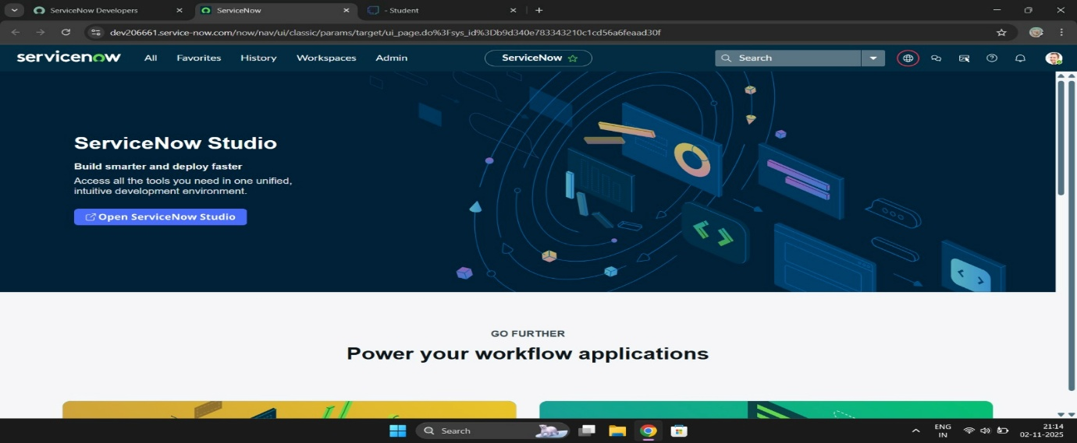
Step 2:

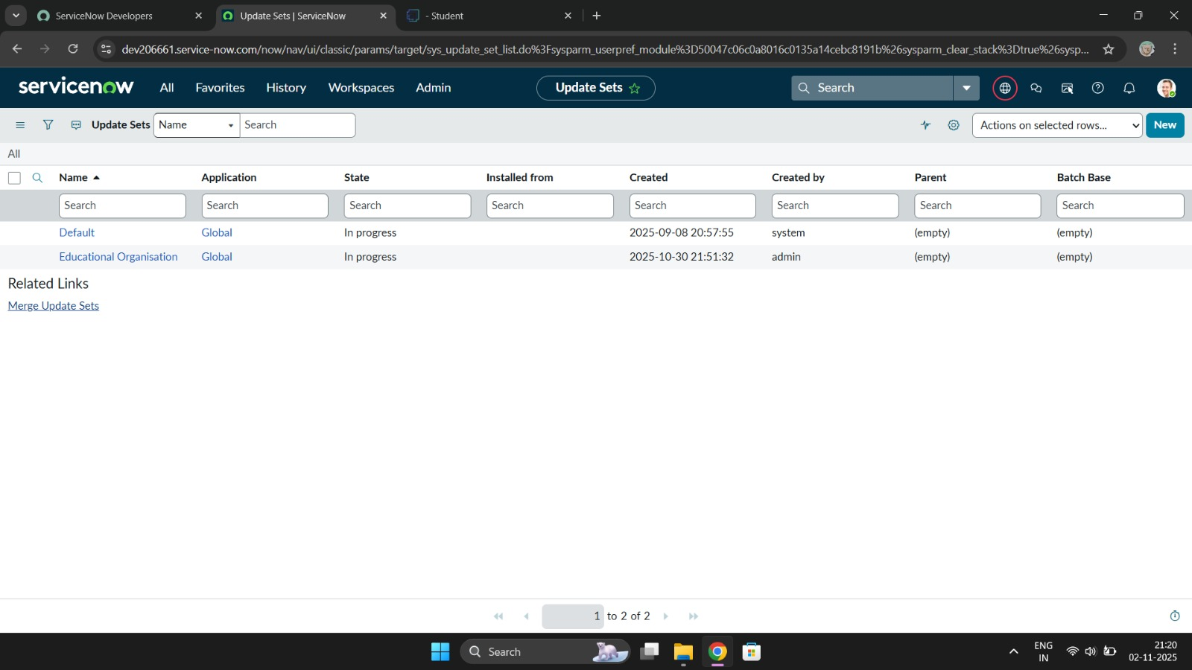

Step 3:
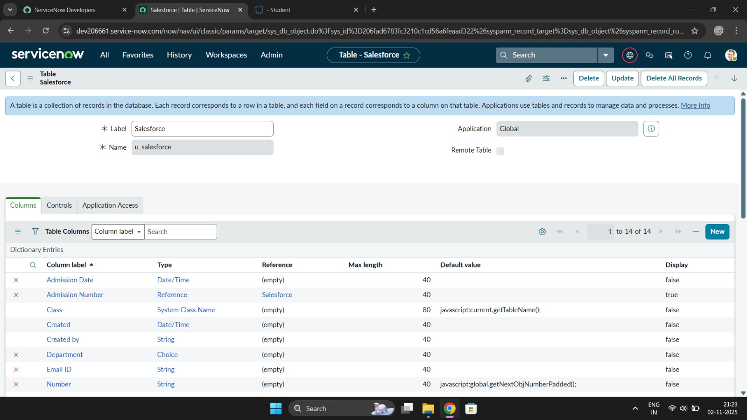
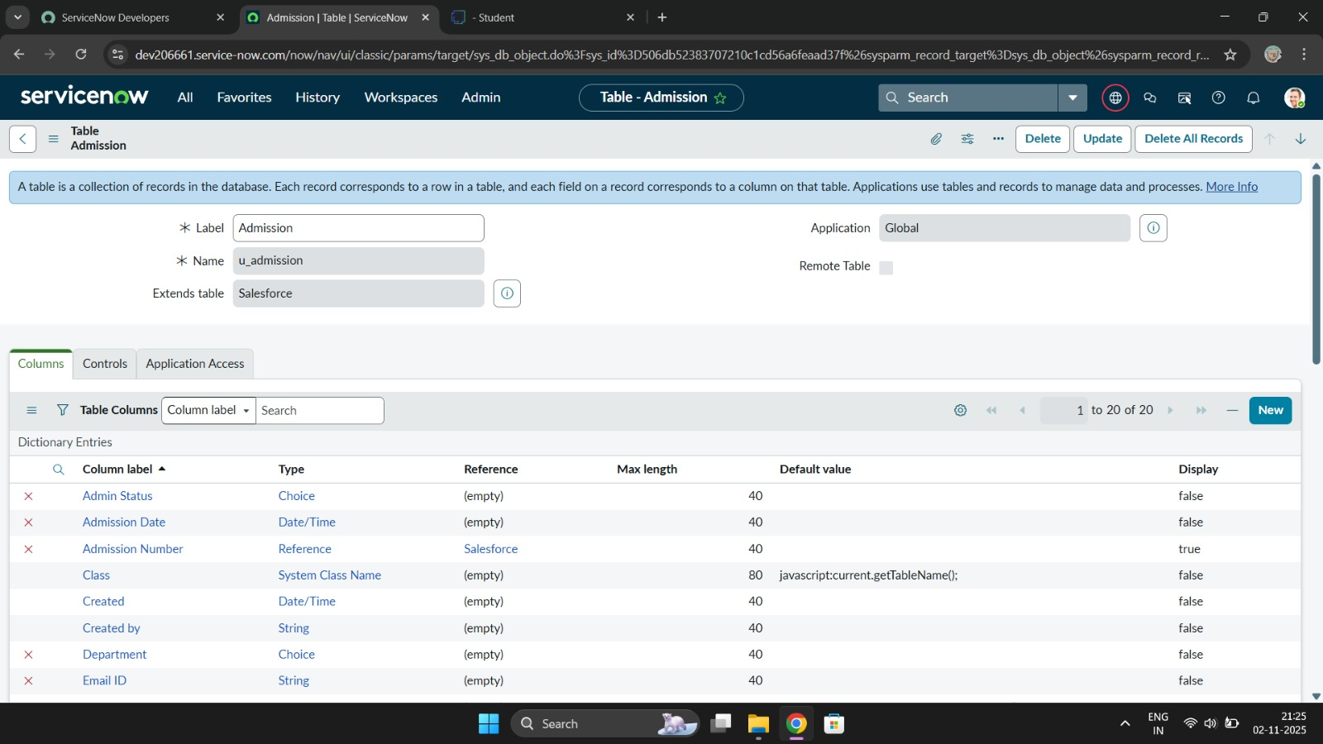
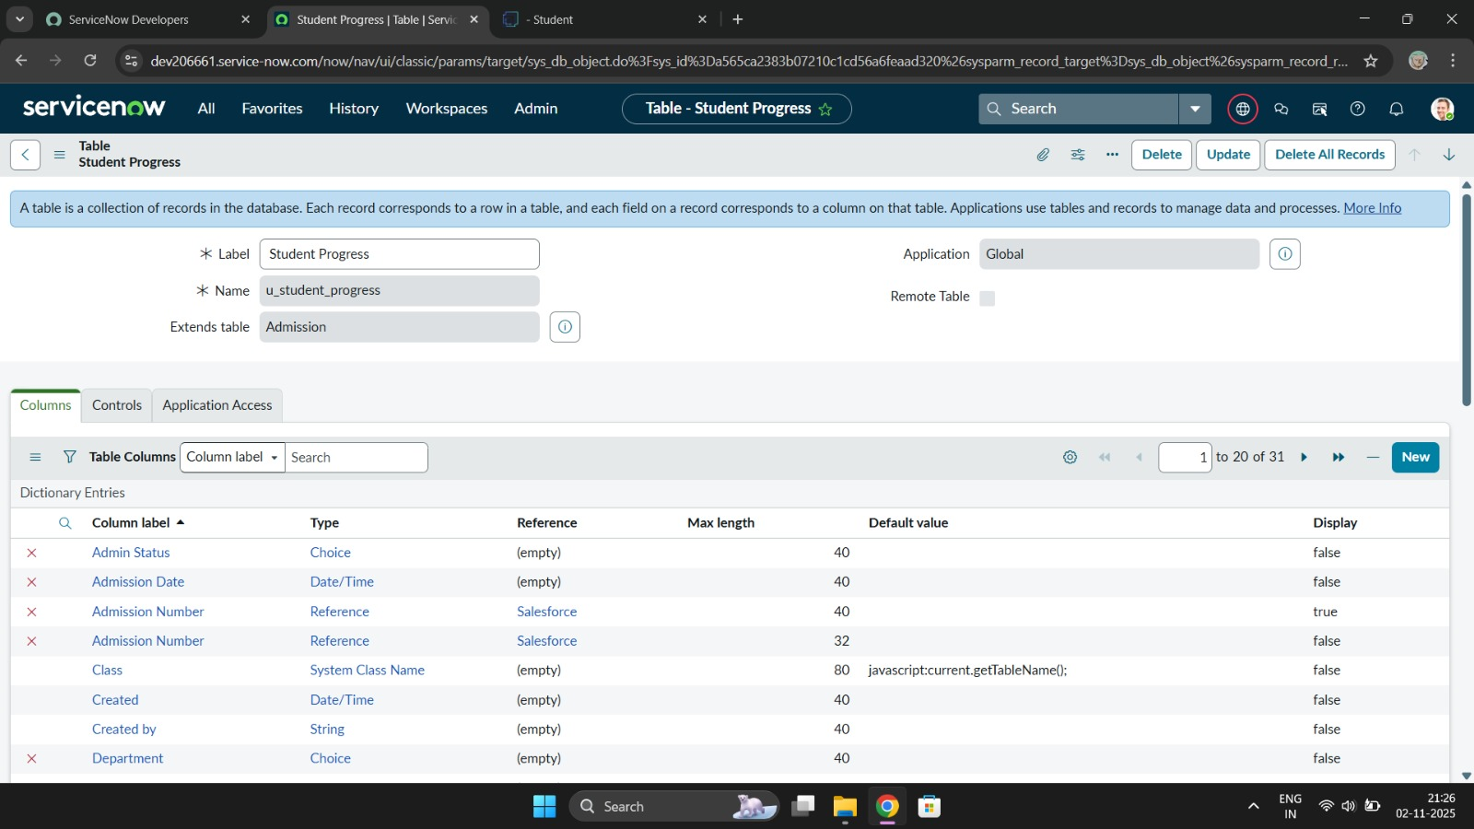

Step 4:
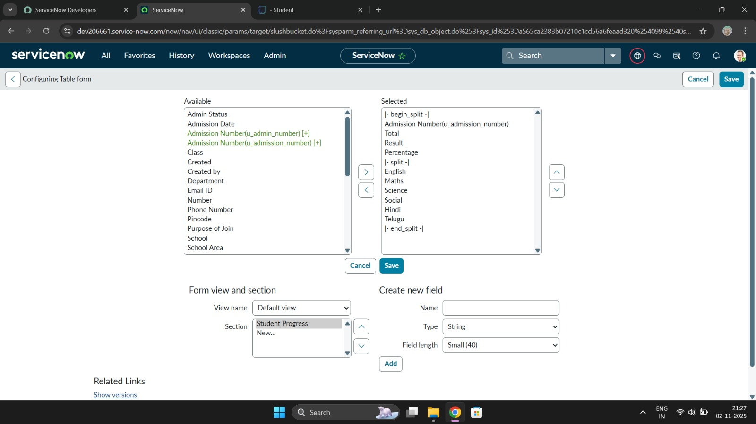
Step 5:
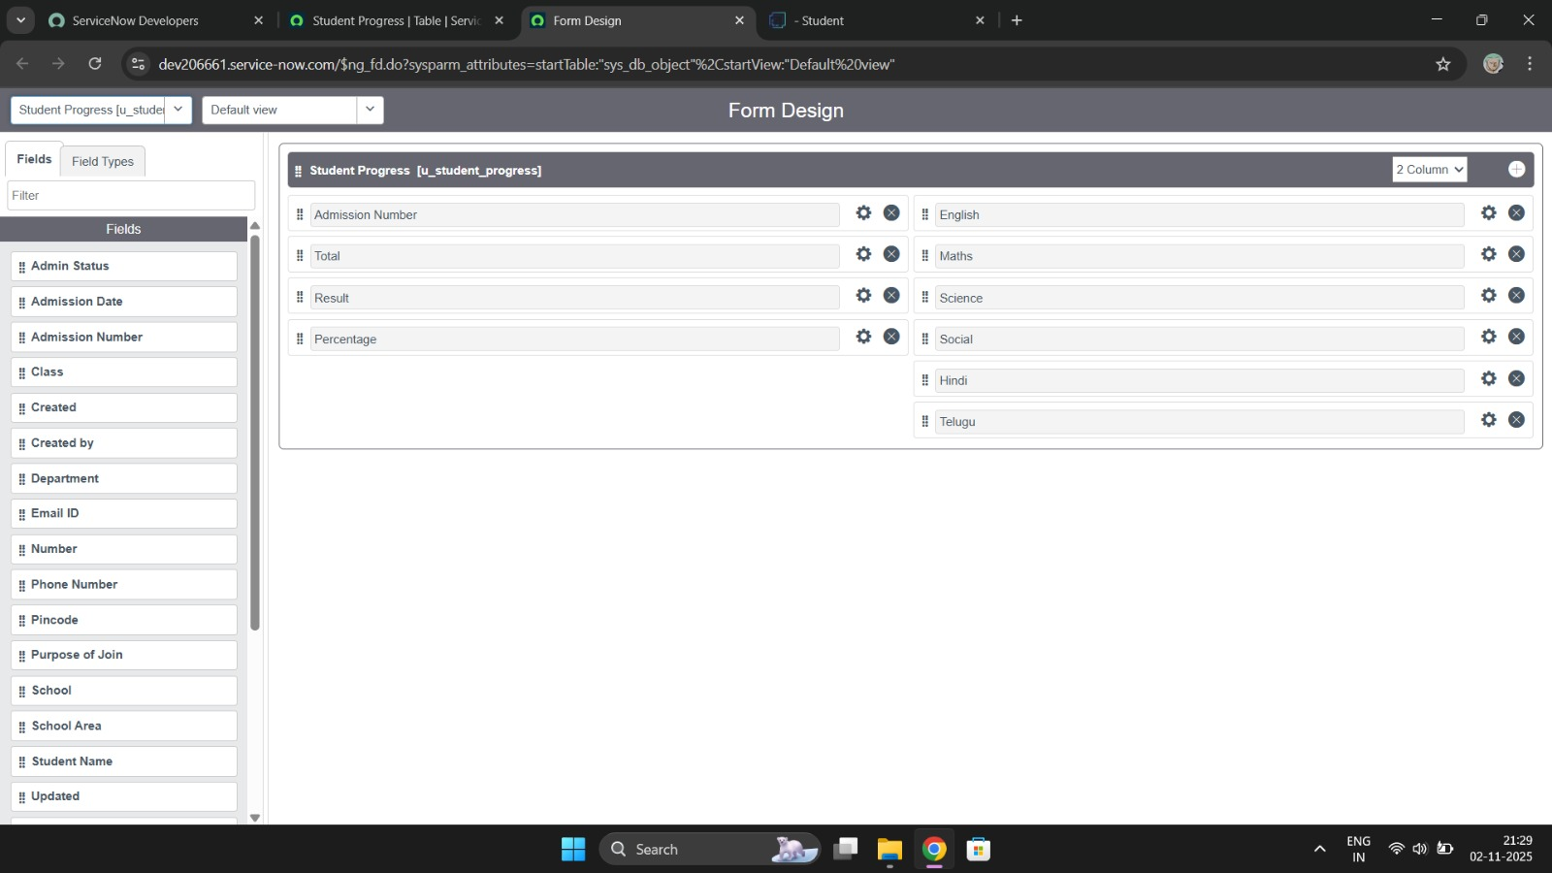

Step 6:
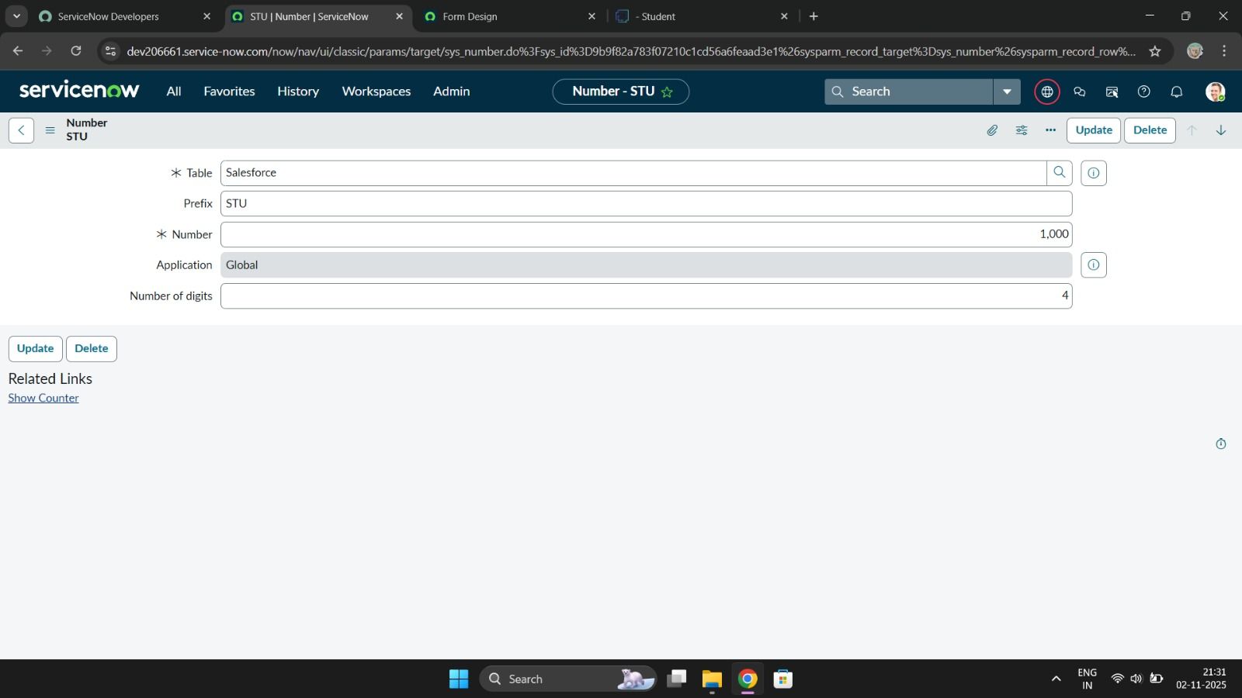
Step 7:
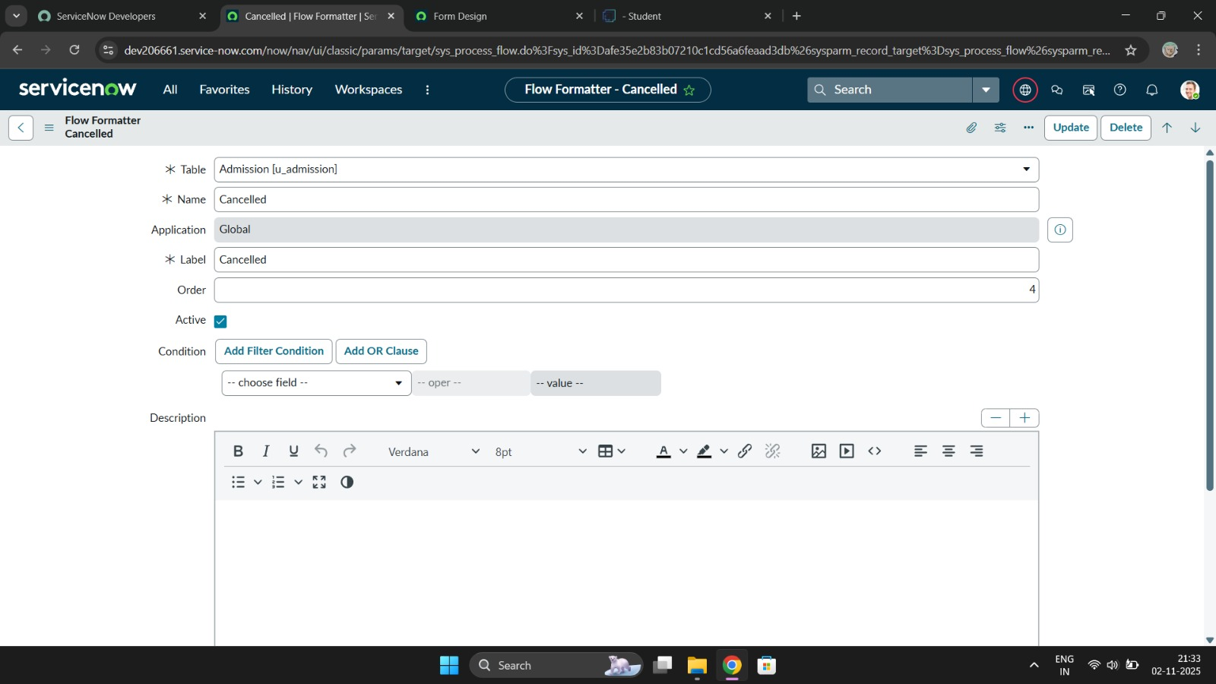

Step 8:
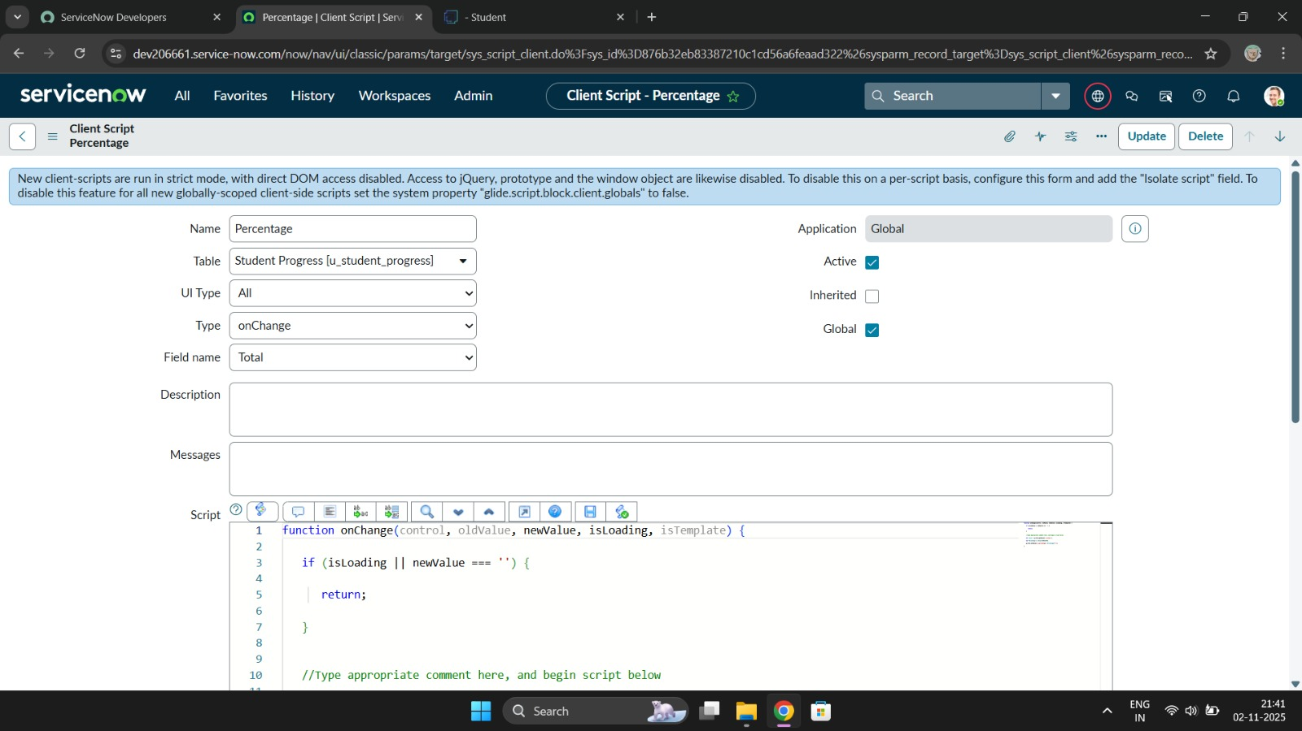
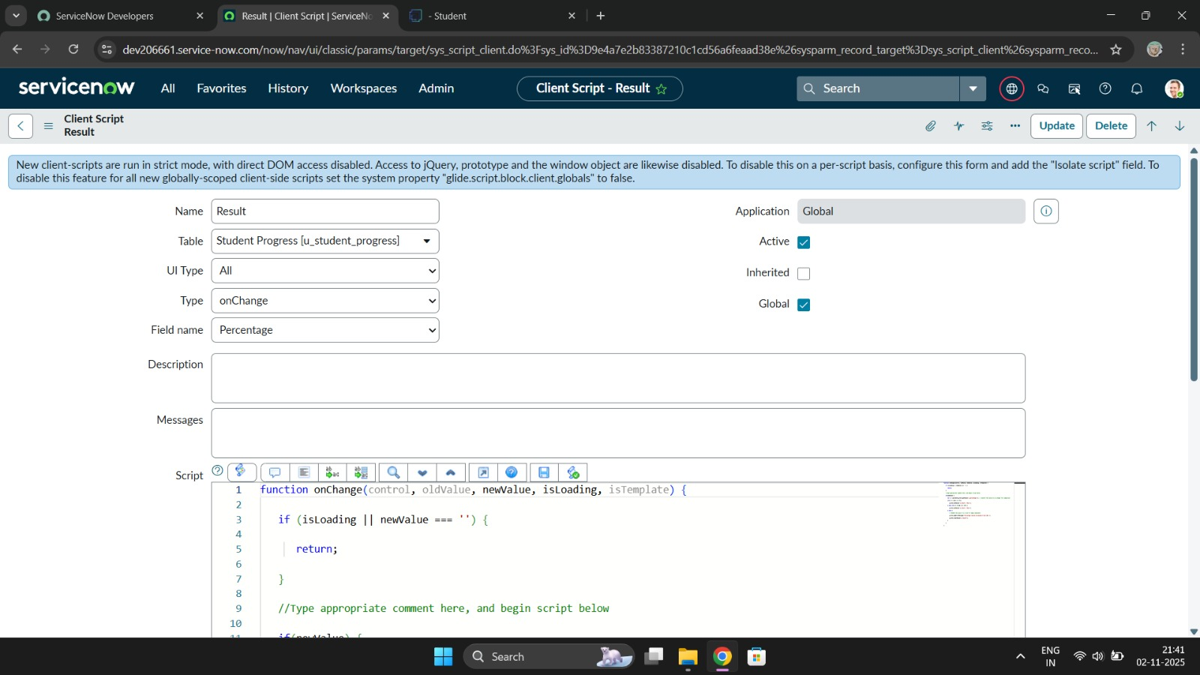

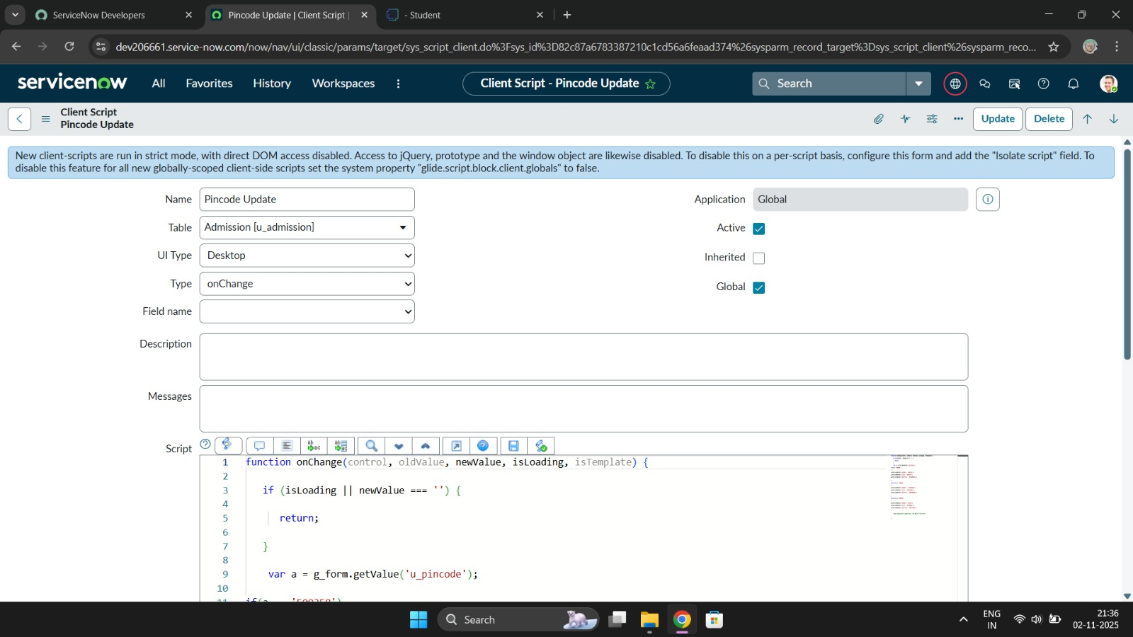
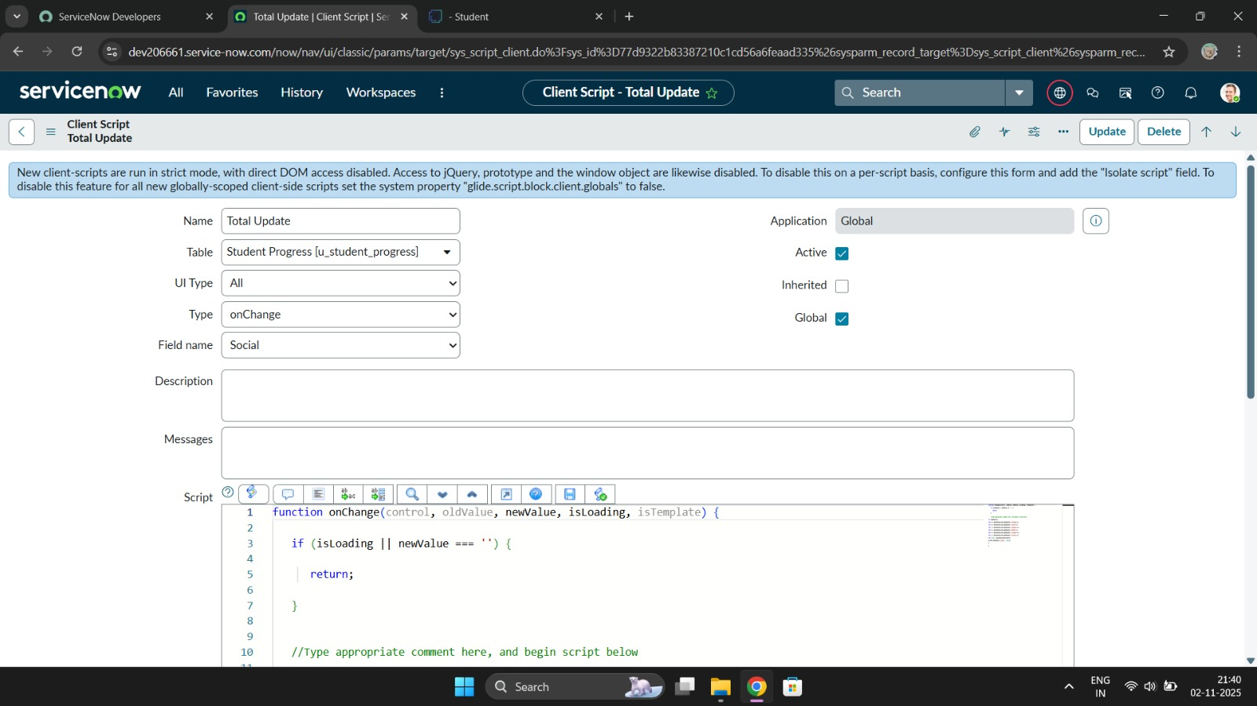

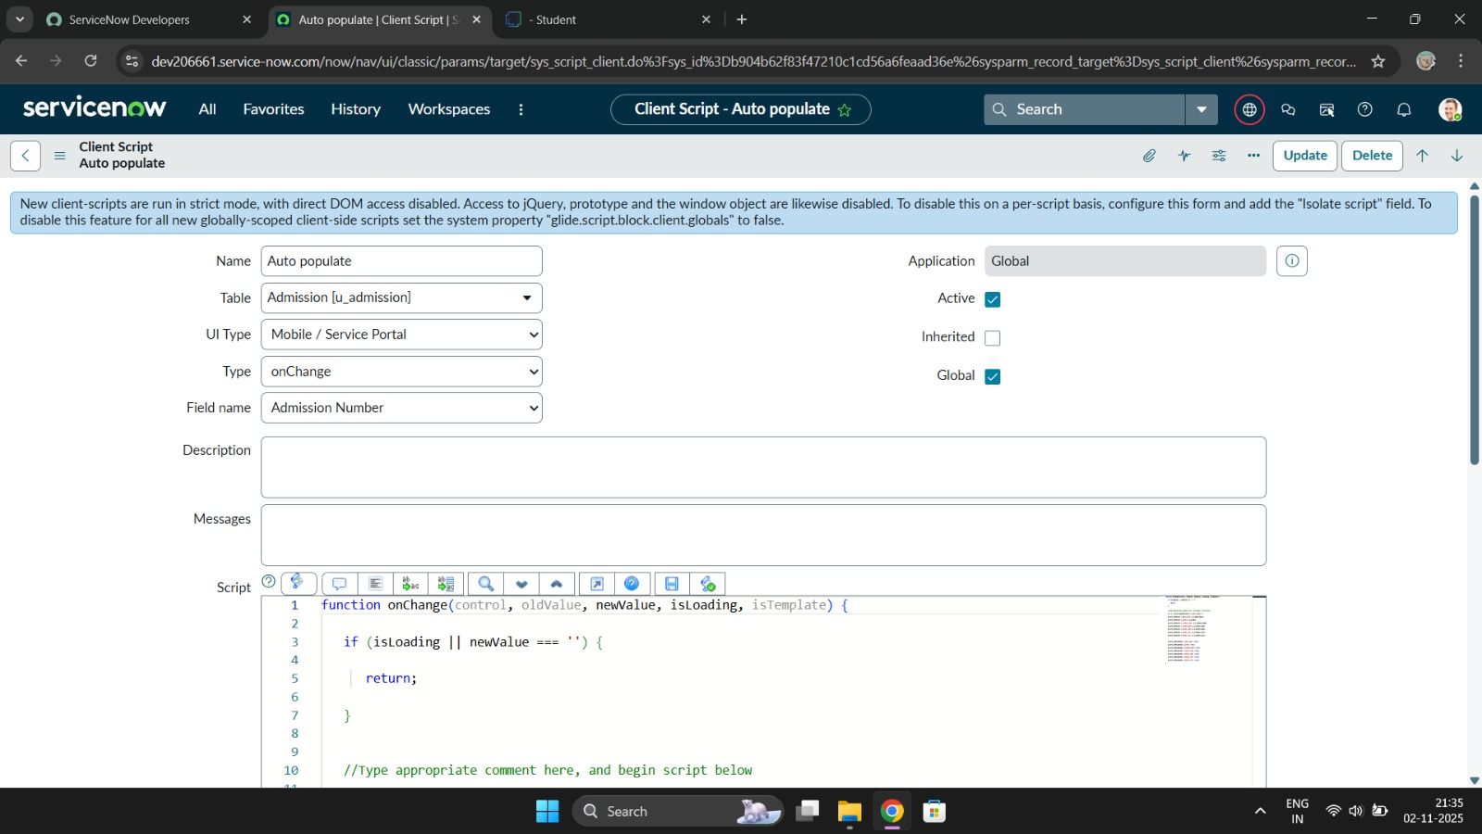
  - Final Result Screenshot

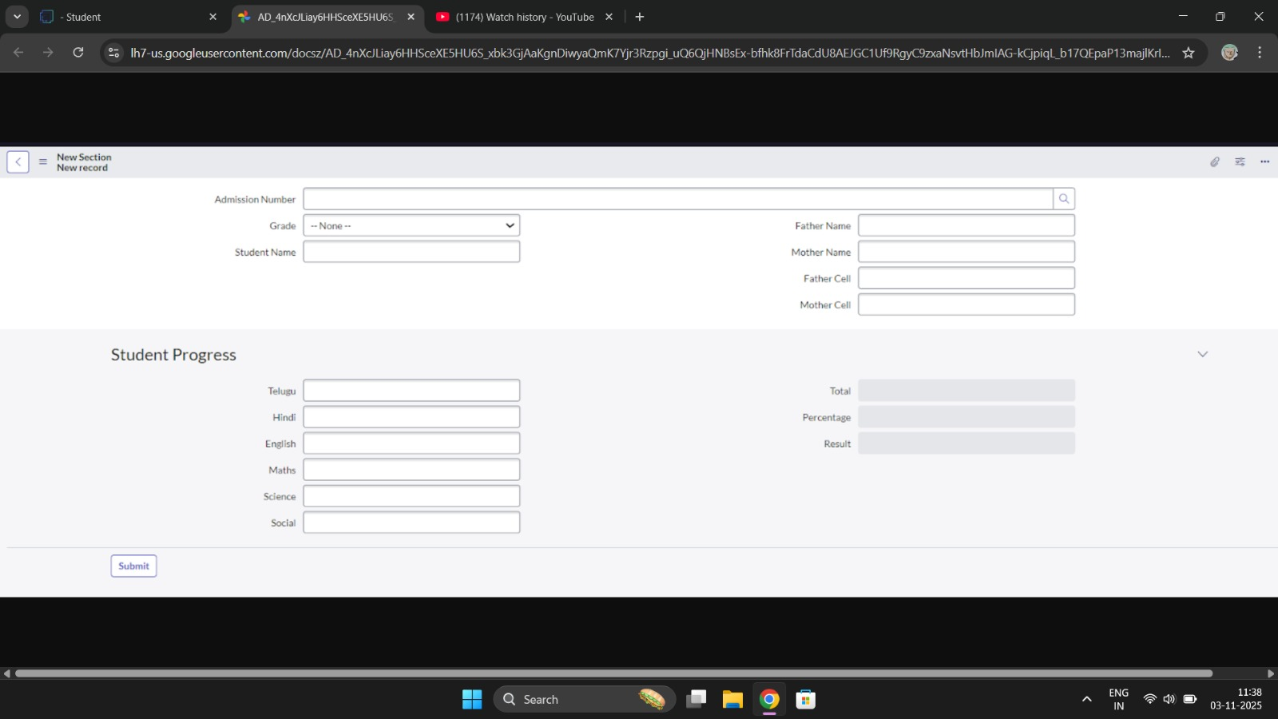

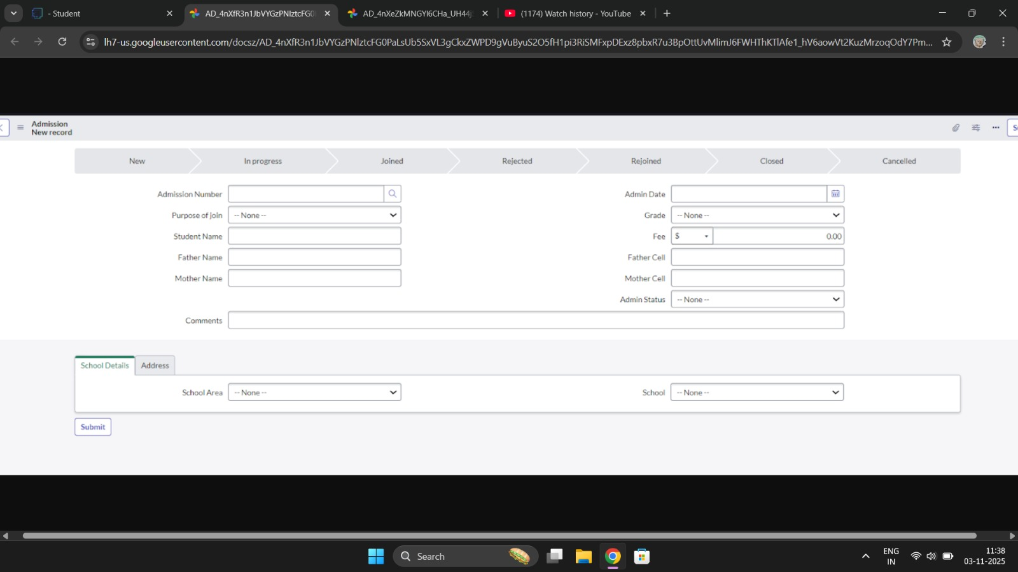
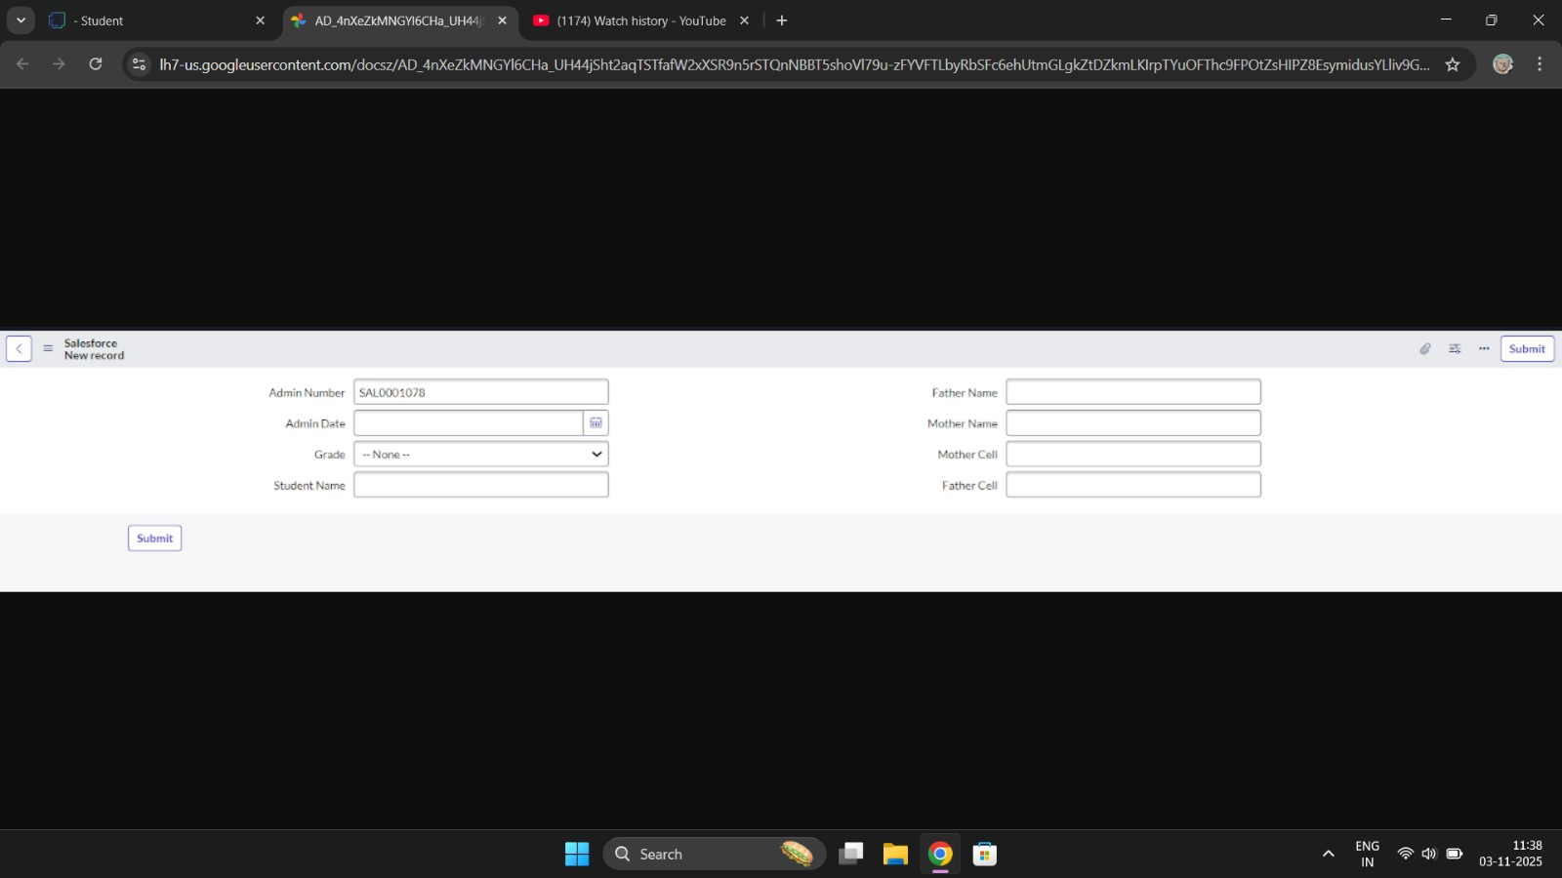

ADVANTAGES & DISADVANTAGES
⬛Advantages
Here are the advantages of using ServiceNow in Educational Organizations in simple points:

Centralized Management System:
All academic and administrative services (IT support, facility requests, student services) can be managed in one platform for easy access and tracking.

Automation of Tasks:
Automates routine processes like student onboarding, IT ticketing, timetable updates, leave approvals, etc., saving time for staff and faculty.

Improved Communication:
Provides a common portal for students, teachers, and administrators to raise issues and get updates, improving transparency and communication.

Custom Dashboards & Reports:
Institutions can generate reports on staff performance, ticket resolutions, student feedback, and resource usage to make data-driven decisions.

Faster Issue Resolution:
Helps resolve IT and administrative issues quickly through a structured ticketing system and workflow automation.

Enhanced Student and Staff Experience:
Self-service portals allow users to submit requests, check status, and access FAQs without manual intervention.

Disadvantages
Here are the disadvantages of using ServiceNow in Educational Organizations in simple points:

Complex Setup:
ServiceNow is designed mainly for enterprises; setting it up for educational workflows can be complicated and time-consuming.

High Cost:
ServiceNow is a paid platform, and licensing costs can be expensive for schools or colleges with limited budgets.

Requires Technical Expertise:
Customizing workflows or dashboards may require skilled IT professionals familiar with ServiceNow development.

Overkill for Small Institutions:
For small schools or colleges with simple requirements, ServiceNow may be too advanced or unnecessary.

Training Required:
Staff, faculty, and students may need training to use the platform efficiently, which can take time and effort.

CONCLUSION
In conclusion, implementing the “Educational Organisation Using ServiceNow” project
provides significant advantages to academic institutions. By utilizing the powerful features of

ServiceNow, educational organizations can efficiently manage student services, staff requests,
IT support, and administrative tasks in a centralized and automated platform. This not only enhances productivity and transparency but also improves the overall experience for students, teachers, and administrators. Therefore, ServiceNow serves as a modern and effective
solution for streamlining daily operations within educational institutions.

FUTURE SCOPE
- Integrate advanced analytics dashboards for student and staff performance tracking
- Enable automatic notifications for exam schedules, admission status, and fee reminders
- Develop a mobile-friendly or dedicated mobile application for easier access
- Implement role-based access controls for administrators, teachers, students, and parents
- Include AI-powered chatbots for student queries and support services
- Integrate online learning platforms and digital libraries within ServiceNow
- Add attendance tracking and automated report card generation
- Enable cloud backup and enhanced data security for academic records

- APPENDIX

    - Source Code: No external code; used ServiceNow platform
    - Dataset Link: Not applicable
    - GitHub & Project Demo: https://github.com/ai22mohamedfarith-cyber/Educational-Organization-Using-ServiceNow.git

